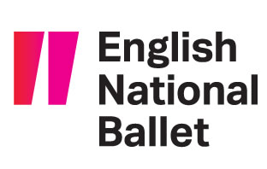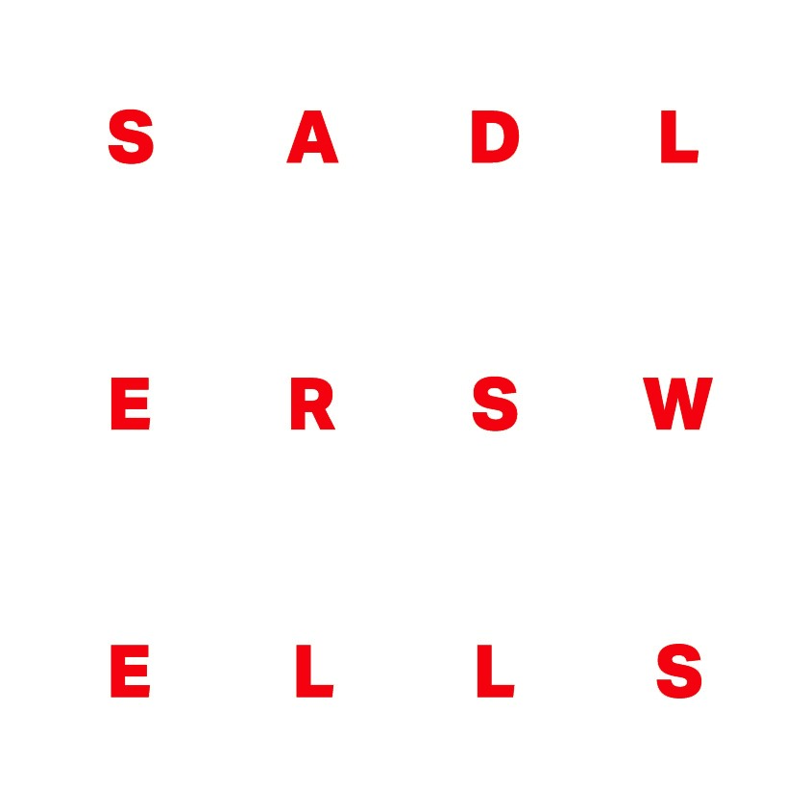

East London Dance, English National Ballet, Sadler’s Wells and Studio Wayne McGregor announce new collaboration as East London shapes up to become a world-leading hub for dance

A collective of the UK’s leading dance organisations – East London Dance, English National Ballet, Sadler’s Wells and Studio Wayne McGregor – has announced a new collaborative initiative to drive a shared vision for East London to become a world-leading hub for dance.

By 2021, within a couple of miles of Stratford, at current count there will be:

16 new dance studios
two production studios
a new 600-seat dance theatre
two internationally renowned touring dance companies
a Hip Hop Academy, a Ballet School and a Choreographic School

These new facilities will join an already vibrant dance sector, spearheaded by East London Dance since their formation in 1987. East London has long been a breeding ground for talent, particularly in hip-hop, with internationally renowned companies such as Boy Blue Entertainment and Avant Garde Dance originating there.
All four organisations will be embedded in East London by 2021: East London Dance has been based in Stratford for almost three decades; Studio Wayne McGregor will open their new home, the first artist-led venue in Queen Elizabeth Olympic Park in Here East, at the start of 2017; English National Ballet and English National Ballet School will unite in a new purpose-built home in Canning Town in 2018; Sadler’s Wells will open an additional venue in East London in 2021, on the Stratford Waterfront site as part of the Olympicopolis project.
As these world-class facilities transform the physical landscape and creative opportunities in East London, the four Arts Council England National Portfolio organisations will work collaboratively to ensure the strongest possible offer for dance is delivered for artists and audiences. Together, the group will look at: schools and community engagement; artist development and commissioning; training and routes to employment; programming and audience development; joint festivals and events. Through East London Dance’s networks the group will connect to all of the dance companies, artists and organisations active in East London to ensure that East London’s communities and their needs, interests and ambitions remain central to developing a vision for dance.

East London Dance is the leading producer of creative dance experiences for the people of east London and beyond. It is embedded in, and draws energy and creativity from the diversity and eclecticism of East London, producing inspirational projects and events and nurturing the next generation of artists and professionals. There were very limited dance studios and stages in East London when the organisation first started in 1987, so the programme grew by placing dance into the heart of the community – bringing world class artists to the streets, estates and public spaces of Newham and beyond and producing ambitious participatory productions. East London Dance were part of the driving force that led to Stratford Circus Arts Centre opening in 2001 securing a high quality home for dance for the area, and where they have been a resident artistic partner since. They collaborate widely and are a sector leader in empowering youth leadership; are a launch pad for diverse artists to gain national and international recognition; and embed progression routes throughout their work to position talented East Londoners on high profile stages and events.
The organisation’s considerable knowledge, networks and experience built over almost three decades will ensure that local artists and communities can both thrive within and significantly drive the shared future for dance. This will be enabled through some of East London Dance’s existing initiatives such as the Dance Enterprise Hub offering skills development and creative incubation for artists to establish sustainable careers and businesses; The Fi.ELD providing training and professional experience for 16-25 year olds; and the East London Dance Weekenders presenting performances that embrace and explore current topics and trends that reflect contemporary life in East London.
English National Ballet and English National Ballet School’s new joint home in East London, will create a centre that combines state-of-the-art training facilities, teaching and rehearsal studios alongside a unique production space unrivalled in the capital. The joint home will be based at London City Island E14, a new neighbourhood from Eco World Ballymore, a short distance from Canning Town and adjoined to Trinity Buoy Wharf.
The new building is being designed by leading architects Glenn Howells Architects, and will include eight large studios including a theatre-size studio space, with fly tower, for the development and rehearsal of productions and creation of new commissions, state of the art training and rehab facilities, a music room for the English National Ballet Philharmonic, and digital infrastructure which will allow both organisations to capture and share work and engage with audiences around the UK and the rest of the world. The new building has been designed so it can be used for any theatre production, not only dance.

The building will include two dedicated creative learning spaces and a large rehearsal studio for participation events and English National Ballet’s ground-breaking Dance for Parkinson’s programme. The provision of dedicated spaces will transform English National Ballet’s offer for children, young and older people, vulnerable and marginalized sectors of the local community. The building will also be open for artists and arts organisations from East London to help further English National Ballet’s engagement partnerships and house spaces for creative dialogue, collaborations, debate, and choreographic exploration.

Sadler’s Wells
Sadler’s Wells plans to open a new, mid-scale theatre in East London in 2021 which, alongside its other stages, will enable it to present the full spectrum of dance in venues that are appropriate for the work and to offer a stage to a range of artists it cannot currently present. Planned by the London Legacy Development Corporation and supported by The Mayor of London, this new venue is part of the Olympicopolis project that will feature a new world-class cultural and higher education quarter. Sadler’s Wells is one of four organisations that will occupy the Stratford Waterfront site, located opposite the London Aquatics Centre in Queen Elizabeth Olympic Park. Its new building will include a 600-seat theatre, a Choreographic School, a Hip Hop Academy and flexible spaces for research, development and production of dance work. Being part of the new culture and university complex with the V&A, UAL’s London College of Fashion and UCL will allow Sadler’s Wells to provide a crucial resource for the development of dance in the UK, as well as new opportunities for local community and arts organisations through co-productions, training, skills sharing and engagement projects.

Studio Wayne McGregor is the creative engine for choreographer and director Wayne McGregor, and the home of his life-long choreographic enquiry into thinking through and with the body. The Studio’s new home as part of Here East in Queen Elizabeth Olympic Park will open at the start of 2017. It will be the first artist-led venue in the Park; an experimental environment comprising three studios, including two of the largest in London, and a fluid series of collaborative workspaces which artists will be invited to use for free to make new work. Studio Wayne McGregor encompasses McGregor’s own touring company of dancers, Company Wayne McGregor (Resident Company at Sadler’s Wells); creative collaborations across dance, film, music, and visual art; specialised learning and engagement programmes for individuals and communities; artist development initiatives; and collaborative research programmes across the interface of the arts with science, technology and academic research. Studio Wayne McGregor will be a game changer for artists, creativity, collaboration and play.
Here East is transforming the former Press and Broadcast Centres in Queen Elizabeth Olympic Park into a world-class centre of innovation and enterprise. To have Studio Wayne McGregor as one of the key organisations based in this complex alongside other academic institutions, start-up businesses, established global companies, investors and social enterprises, in one space, will allow further cross disciplinary collaborations and promote innovation.
Polly Risbridger, Director of East London Dance, said: “It’s an incredibly exciting time for dance in East London with the imminent arrival of these world class facilities. But buildings are only part of the picture. It is the people, the artists, the producers, the educators, the dancers that will make east London a world-leading hub for dance. And this is what East London Dance can bring to this exciting collaboration – the very best talent who are innovating and pushing the artform we all love, and hungry for opportunity. I look forward to working closely with the incoming organisations to strengthen and grow the dance offer here and to open up the most amazing array of opportunities.”
Tamara Rojo, Artistic Director of English National Ballet and English National Ballet School, said: “I am incredibly proud of what we have been able to achieve in the last few years, and I now want to push the Company to the forefront of excellence and innovation by developing top talent, collaborating with the best artists at every stage of the artistic process, and creating an environment to produce ground-breaking and lasting new work that will inspire and excite audiences.
“I want to create a new space that allows us to produce and rehearse amazing work. Not only that, I want a building that will be available for other artistic organisations to rehearse too, whether they are staging opera, musicals or theatre. I want the space to echo to the sound of creative Britain.”
Alistair Spalding, Artistic Director and Chief Executive of Sadler’s Wells, said: “We are delighted to be joining the other excellent dance organisations who will be represented in East London to create what we hope will be an inspiring hub for dance.”
Choreographer and director, Wayne McGregor, said: “I am so pleased to open Studio Wayne McGregor in east London, where I started my career more than 20 years ago. Our space will be a place for imaginative freedom: a mixing house for creators and inventors of art where art forms cross paths with technological innovation, experience with enthusiasm, doers with thinkers. It’s exciting to think that in a year’s time the space will be built and our programmes will be running, with artists working within our walls, and young people and communities in east London accessing these artists’ enormous wealth of creative passion. I look forward to the contribution Studio Wayne McGregor can make to the existing and developing imaginative landscape of east London.”

Press contacts:
For East London Dance press enquiries, contact Jennifer Reynolds PR jenn@jenniferreynoldspr.co.uk / 07736 84 22 37
For English National Ballet press enquiries, contact Robert James, PR Manager on robert.james@ballet.org.uk / 020 7590 2933
For Sadler’s Wells press enquiries, contact Caroline Ansdell, Interim Senior Press Manager Caroline.Ansdell@sadlerswells.com / 020 7863 8125
For Studio Wayne McGregor press enquiries, contact Polly Hunt, Director of Development and Communications on polly@waynemcgregor.com / 020 7278 6015

Notes to Editors
About East London Dance
Enriched by 28 years of experience, East London Dance is the leading producer of creative dance experiences for the people of East London and beyond. We produce inspirational projects and events to engage our diverse local communities in dance, and nurture the next generation of artists and professionals. We champion enterprise, collaboration and innovation in order to create dance of exceptional quality that is seen regionally, nationally and internationally. We specialise in a tailored and responsive approach that places our communities and their needs, interests and ambitions at the centre of our work. In the last three years we have attracted diverse live audiences of over 88,000, of which over 50% are least likely to attend the arts. We have engaged and inspired over 11,000 people to participate in dance activities and launched the careers of many successful artists, choreographers and companies.
East London Dance is based at Stratford Circus Arts Centre in the vibrant borough of Newham, and predominantly works across the London boroughs of Barking and Dagenham, City of London, Hackney, Havering, Newham, Redbridge, Tower Hamlets and Waltham Forest. www.eastlondondance.org
About English National Ballet
English National Ballet has a long and distinguished history. Founded in 1950 as London Festival Ballet by the great English Dancers Alicia Markova and Anton Dolin, it has played a major role in the growth and history of ballet in the UK. Today, English National Ballet is renowned for taking world-class ballet to the widest possible audience through its national and international tour programme, offsite performances at festivals including Glastonbury and Latitude, its distinguished orchestra English National Ballet Philharmonic, and being a UK leader in creative learning and engagement practice and delivery, building innovative partnerships to deliver flagship programmes such as English National Ballet’s Dance for Parkinson’s. Under the artistic directorship of Tamara Rojo, English National Ballet has gained new acclaim as it introduces innovative new works to the Company’s repertoire while continuing to honour and reinvigorate traditional ballet. www.ballet.org.uk
About English National Ballet School
English National Ballet School is a world-renowned specialist training centre for aspiring and highly talented young ballet dancers aged 16 to 19. Founded in 1988 by English National Ballet, today the school exists as a separate entity but maintains strong links with its parent company, sharing its commitment to excellence and access. Its mission is to nurture and develop the next generation of world-class dance artists; artists who are confident and versatile, able to push boundaries and bring their creativity to the fore. Students participate in a three-year programme, validated by Trinity College London, with 90% of graduates joining prestigious dance companies worldwide. Currently a third of the dancers at English National Ballet are graduates of the School.
About Sadler’s Wells
Sadler's Wells is a world-leading dance house, committed to producing, commissioning and presenting new works and to bringing the best international and UK dance to London and worldwide audiences. Under the Artistic Directorship of Alistair Spalding, the theatre’s acclaimed year-round programme spans dance of every kind, from contemporary to flamenco, Bollywood to ballet, salsa to street dance and tango to tap. Since 2005, it has helped to bring over 100 new dance works to the stage and its award-winning commissions and collaborative productions regularly tour internationally. Sadler’s Wells supports 16 Associate Artists, three Resident Companies, an Associate Company and two International Associate Companies. It also nurtures the next generation of talent through research and development, running the National Youth Dance Company and a range of programmes including Wild Card, New Wave Associates, Open Art Surgery and Summer University. Located in Islington, north London, the current theatre is the sixth to have stood on the site since it was first built by Richard Sadler in 1683. The venue has played an illustrious role in the history of theatre ever since, with The Royal Ballet, Birmingham Royal Ballet and English National Opera all having started at Sadler’s Wells. Sadler’s Wells is an Arts Council National Portfolio Organisation and currently receives approximately 10% of its revenue from Arts Council England.
Studio Wayne McGregor
Studio Wayne McGregor is the creative engine for choreographer and director Wayne McGregor, and the home of his life-long choreographic enquiry into thinking through and with the body. It describes the dynamic team of individuals and resources that supports his vision, and comprises dance artists, writers, composers, film-makers, visual artists, scientists, designers, architects, stage technicians, software engineers, administrators and producers who form his collaborative network.
Studio Wayne McGregor fuels the breadth of McGregor’s creative work including the development and touring of signature works on his ensemble of world-class dancers, Company Wayne McGregor (Resident Company at Sadler’s Wells); a portfolio of international commissions and artistic collaborations across genres including dance, visual arts, film, theatre and opera; a highly specialized programme of creative learning for individuals and communities; artist development initiatives; and collaborative research projects across the interface of the arts with science, technology and academic research.
McGregor is also Resident Choreographer at The Royal Ballet, where his productions are acclaimed for their daring reconfiguring of classical language. McGregor is regularly commissioned by and has works in ballet companies around the world including Paris Opera Ballet, New York City Ballet, Bolshoi Ballet, Royal Danish Ballet and San Francisco Ballet, and choreographs for theatre, film, fashion, music videos and TV. He has an Honorary Doctor of Science from Plymouth University and an Honorary Doctor of Letters from his alma mater, University of Leeds. He is Professor of Choreography at Trinity Laban Conservatoire of Music and Dance and a member of the King's College London Circle of Cultural Fellows. In 2011 he was awarded a CBE for Services to Dance. www.waynemcgregor.com

