1000 Pieces Puzzle
Application Form
International Dance Exchange
Part of the Dance Enterprise Hub

Personal Details
First Name
Surname

Date of Birth
NB. The programme is aimed at artists aged 18-30. Artists over the age of 30 may apply but if selected will have to cover the costs of their own travel, accommodation and food.
Gender
Address

Post Code
Telephone
Email
Do you have any access or additional support needs?
If yes, please specify

Do you have a valid UK/EU passport?
If not, what passport do you have and do you require a VISA to be able to travel to Belgium?
Availability
Please confirm you are available for the exchange programme dates
13 – 19 February 2017 (inclusive)  Belgium |  |  |  | 28 February - 5 March 2017 (inclusive)  London
NB you will not be eligible for the residency programme if you are not available on all of the above dates
Your Application – Dance Experience and Expression of Interest
You may submit this section by answering the questions in writing or to camera and submitting a web-link (eg vimeo or youtube). If you chose to film your answers we just need to be able to see and hear you clearly (filming yourself on your phone is fine).
You have a maximum of 250 words for each question for a written entry and a maximum of 2 minutes on video per question. (If you do submit a film please copy and paste the relevant link into the box below)
What dance & choreographic experience do you have? (training, performances, battles, awards, championships, etc.) (max 250 words or 2 minute film)

What do you want to get out of the programme?

(max 250 words or 2 minute film)
How do you see yourself contributing to the dance scene in the future?
(max 250 words or 2 minute film)
Supporting Material
Please submit a video of your dance work; this could be freestyle or a piece of choreography. (Between 1 and 5 minutes) It’s more important that we get a sense of your dance skill rather than flashy footage, a film shot in the studio would be suitable. Please submit a web-link to your video (eg vimeo or youtube) with a short description of the content.
Additional Support
There may be a limited number bursaries and other support available if you are in financial hardship, (i.e you live outside of London, receive benefits or can’t afford the participant fee) if this applies to you please indicate below.
Dance Styles
Please tick all the dance styles that apply to you. | Afro Beats |  |  |  |  | Afro & Caribbean Dance
 | Contemporary |  |  |  |  | Dancehall
 | Hip Hop |  |  |  |  | House
 | Krump |  |  |  |  | Other
 | If ‘Other’ please specify:

Please complete this application form and return to East London Dance by:
21 November 9am

Please email your application to office@eastlondondance.org
Please note: hard copies will not be accepted.

By submitting your details, you are indicating your consent to receiving marketing emails from East London Dance and Cindy Claes Productions. Please tick the box if you do not wish to receive such messages

If you have any questions please contact East London Dance on
020 8279 1050 or email office@eastlondondance.org

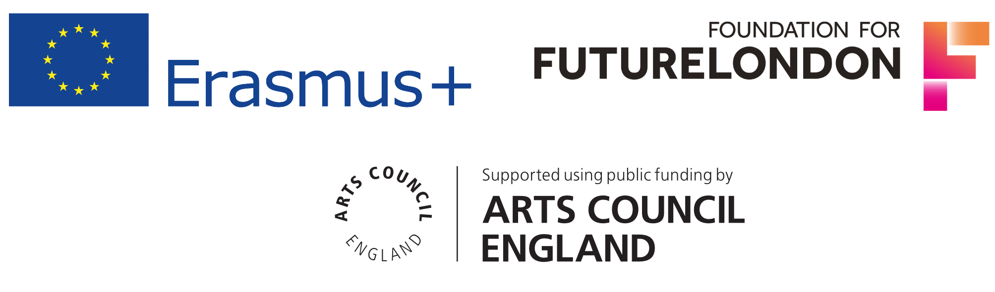

EQUAL OPPORTUNITIES MONITORING
East London Dance want to ensure this opportunity is accessible to all eligible participants. It will help us to monitor the effectiveness the application process if you could supply the following information. The information on this form will be used anonymously for statistical monitoring only and will have no bearing on your application.

Nationality
Do you consider yourself to have a disability as defined by the Equality Act 2010? | Yes |  | No

Ethnic Origin (please tick the box which most closely relates to you)

Asian or Asian British: | Bangladeshi: |  | Indian:
 | Pakistani: |  | Other Asian background:
 | If ‘Other’ please specify:
Black or Black British: | African: |  | Caribbean
 | Other black backgrounds:
 | If ‘Other’ please specify:
Chinese or Other Ethnic Group | Chinese |  | Other ethnic group
 | If ‘Other’ please specify:
Mixed: | White and Asian: |  | White and Black African:
 | White and Black Caribbean: |  | Other mixed background
 | If ‘Other’ please specify:
White | British: |  | Irish:
 | Other white background:
 | If ‘Other’ please specify:

