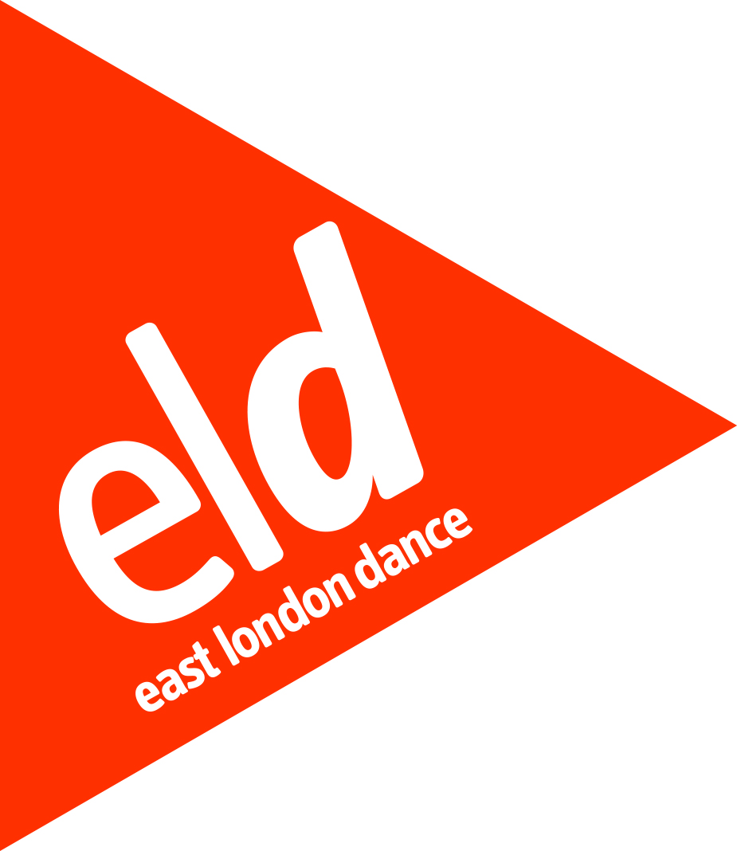

Youth Advisory Board
East London Dance
Application Form

Personal Details
First Name
Surname

Date of Birth
NB. Youth Advisory board Members must be between 14-21
Gender
Address

Post Code
Telephone
Email
Do you have any access or additional support needs?
If yes, please specify

How did you hear about the East London Dance Youth Advisory Board?
What is your current education/ employment status? | Full-time education Employed full-time  Employed part-time Not currently employed  Self employed  Other (please specify):
Your Application
You may submit this section by answering the questions in writing or by filming yourself and submitting a private web-link (eg Vimeo or YouTube). If you chose to film your answers we need to be able to see and hear you clearly (filming yourself on your phone is fine).
Please write approximately 100 words for each question for a written entry or film appromimately 1 minute per question on video. You are also welcome to answer all 4 questions on one video up to 4 minutes in length. (If you do submit a film please copy and paste the relevant link or links into the boxes below)
1. Tell us about you. What are your hobbies and interests? What are you passionate about? What’s important to you? (approx. 100 words or 1 minute film)
2. Tell us why you’re interested in being part of our Youth Advisory Board.

(approx.100 words or 1 minute film)
3. Tell us why you think you’d be a great candidate. What skills, talent and abilities would you bring to the board? (approx.100 words or 1 minute film)
4. Tell us how you think being on the Youth Advisory Board will benefit you. Are there any particular ways that being on the board will help you develop? (approx.100 words or 1 minute film)

Please complete this application form and return to East London Dance by:
Friday 25th November 5pm. Please email your application (or any questions about completing the form) to bryony@eastlondondance.org

Would you like to be added to the East London Dance mailing list?

 Yes No

EQUAL OPPORTUNITIES MONITORING
East London Dance want to ensure this opportunity is accessible to all eligible participants. It will help us to monitor the effectiveness the application process if you could supply the following information. The information on this form will be used anonymously for statistical monitoring only and will have no bearing on your application.

Nationality
Do you consider yourself to have a disability as defined by the Equality Act 2010? | Yes |  | No

Ethnic Origin (please tick the box which most closely relates to you)

Asian or Asian British: | Bangladeshi: |  | Indian:
 | Pakistani: |  | Other Asian background:
 | If ‘Other’ please specify:
Black or Black British: | African: |  | Caribbean
 | Other black backgrounds:
 | If ‘Other’ please specify:
Chinese or Other Ethnic Group | Chinese |  | Other ethnic group
 | If ‘Other’ please specify:
Mixed: | White and Asian: |  | White and Black African:
 | White and Black Caribbean: |  | Other mixed background
 | If ‘Other’ please specify:
White | British: |  | Irish:
 | Other white background:
 | If ‘Other’ please specify:

